Radius segment
# Source: AI Source: Provided by: [Data Path: Persons Table -> ID Column: 1, Name_En Column: Motasem Essam] -> From: [ChatGPT] on [7/25/2026]
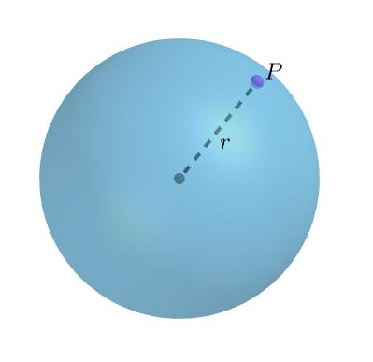
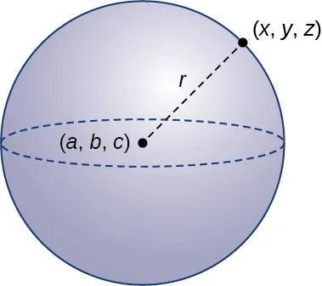
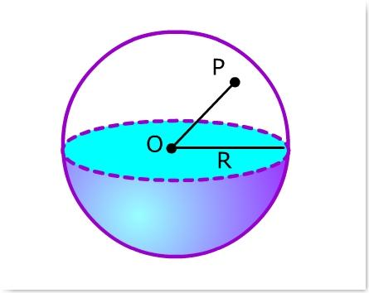

Definition
# Source: AI Source: Provided by: [Data Path: Persons Table -> ID Column: 1, Name_En Column: Motasem Essam] -> From: [ChatGPT] on [7/25/2026]
A radius segment of a sphere is a line segment that connects the sphere’s center to any point on its surface.
For a sphere with center $O$ and a point $P$ on its surface, the line segment $\overline{OP}$ is a radius segment. Its length is the sphere’s radius, commonly represented by $R$ or $r$.
$$\overline{OP}\text{ is a radius segment}$$
$$OP=R$$
Every radius segment of the same perfect sphere has the same length.

Simple Definition
# Source: AI Source: Provided by: [Data Path: Persons Table -> ID Column: 1, Name_En Column: Motasem Essam] -> From: [ChatGPT] on [7/25/2026]
A radius segment is a straight line segment drawn from the center of a sphere to its surface.
- Starting point: The sphere’s center.
- Ending point: A point on the sphere’s surface.
- Length: Equal to the sphere’s radius.

Geometric Representation
# Source: AI Source: Provided by: [Data Path: Persons Table -> ID Column: 1, Name_En Column: Motasem Essam] -> From: [ChatGPT] on [7/25/2026]
Consider a sphere with center $O$ and surface points $A$, $B$, and $C$.
- $\overline{OA}$ is a radius segment.
- $\overline{OB}$ is a radius segment.
- $\overline{OC}$ is a radius segment.
If the sphere’s radius is $R=5\text{ cm}$, then:
$$OA=OB=OC=5\text{ cm}$$
The segments point in different directions, but their lengths are equal.

Key Characteristics
# Source: AI Source: Provided by: [Data Path: Persons Table -> ID Column: 1, Name_En Column: Motasem Essam] -> From: [ChatGPT] on [7/25/2026]
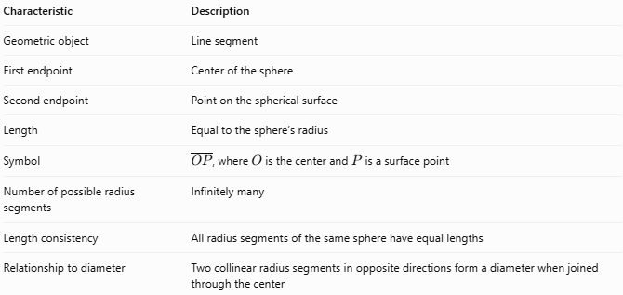
Characteristic | Description
Geometric object | Line segment
First endpoint | Center of the sphere
Second endpoint | Point on the spherical surface
Length | Equal to the sphere’s radius
Symbol | $\overline{OP}$, where $O$ is the center and $P$ is a surface point
Number of possible radius segments | Infinitely many
Length consistency | All radius segments of the same sphere have equal lengths
Relationship to diameter | Two collinear radius segments in opposite directions form a diameter when joined through the center

Mathematical Formulas

Radius Segment Length
# Source: AI Source: Provided by: [Data Path: Persons Table -> ID Column: 1, Name_En Column: Motasem Essam] -> From: [ChatGPT] on [7/25/2026]
For a sphere with center $O$ and surface point $P$:
$$\boxed{OP=R}$$
where:
- $OP$ is the length of the radius segment.
- $R$ is the sphere’s radius.

Relationship to the Diameter
# Source: AI Source: Provided by: [Data Path: Persons Table -> ID Column: 1, Name_En Column: Motasem Essam] -> From: [ChatGPT] on [7/25/2026]
The diameter is twice the radius:
$$\boxed{D=2R}$$
Therefore:
$$\boxed{R=\frac{D}{2}}$$
A radius segment is half the length of a diameter when both lie along the same straight line through the center.

Coordinate Geometry
# Source: AI Source: Provided by: [Data Path: Persons Table -> ID Column: 1, Name_En Column: Motasem Essam] -> From: [ChatGPT] on [7/25/2026]
For a sphere centered at $O\left(a,b,c\right)$ and a surface point $P\left(x,y,z\right)$, the radius segment length is:
$$\boxed{R=\sqrt{{\left(x-a\right)}^{2}+{\left(y-b\right)}^{2}+{\left(z-c\right)}^{2}}}$$
For a sphere centered at the origin $O\left(0,0,0\right)$:
$$\boxed{R=\sqrt{x^{2}+y^{2}+z^{2}}}$$

Worked Examples
# Source: AI Source: Provided by: [Data Path: Persons Table -> ID Column: 1, Name_En Column: Motasem Essam] -> From: [ChatGPT] on [7/25/2026]
Example 1 — Finding the Radius Segment Length
A sphere has center $O$ and a surface point $P$. The sphere’s radius is $7\text{ cm}$. Find the length of $\overline{OP}$.
Solution:
$$OP=R$$
$$\boxed{OP=7\text{ cm}}$$
Example 2 — Finding the Radius from the Diameter
A sphere has a diameter of $18\text{ cm}$. Find the length of each radius segment.
Solution:
$$R=\frac{D}{2}$$
$$R=\frac{18}{2}=9\text{ cm}$$
Therefore, every radius segment of the sphere is $9\text{ cm}$ long.
Example 3 — Using Coordinates
A sphere has center $O\left(1,2,3\right)$, and $P\left(5,5,3\right)$ is a point on its surface. Find the radius segment length $OP$.
Solution:
$$OP=\sqrt{{\left(5-1\right)}^{2}+{\left(5-2\right)}^{2}+{\left(3-3\right)}^{2}}$$
$$OP=\sqrt{16+9+0}$$
$$\boxed{OP=5\text{ units}}$$
Thus, the sphere’s radius is $5$ units.

Radius Segment vs. Related Concepts
# Source: AI Source: Provided by: [Data Path: Persons Table -> ID Column: 1, Name_En Column: Motasem Essam] -> From: [ChatGPT] on [7/25/2026]
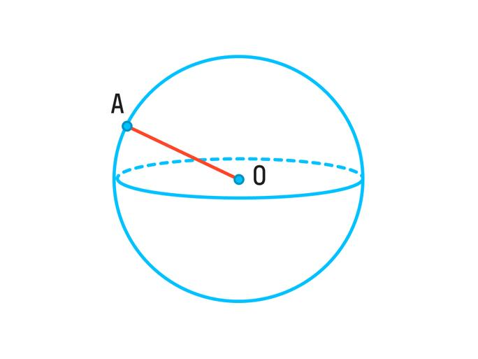
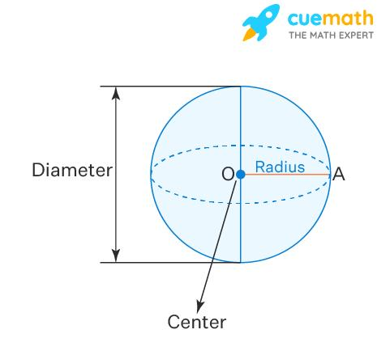
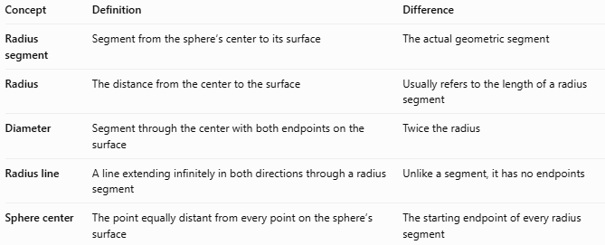
Concept | Definition | Difference
Radius segment | Segment from the sphere’s center to its surface | The actual geometric segment
Radius | The distance from the center to the surface | Usually refers to the length of a radius segment
Diameter | Segment through the center with both endpoints on the surface | Twice the radius
Radius line | A line extending infinitely in both directions through a radius segment | Unlike a segment, it has no endpoints
Sphere center | The point equally distant from every point on the sphere’s surface | The starting endpoint of every radius segment
Important distinction: A radius segment is a geometric object, while the radius usually refers to its numerical length. In everyday mathematical writing, however, the term radius is often used for both.

Applications
# Source: AI Source: Provided by: [Data Path: Persons Table -> ID Column: 1, Name_En Column: Motasem Essam] -> From: [ChatGPT] on [7/25/2026]
Radius segments are useful in:
- Geometry diagrams: Showing the distance from a sphere’s center to its surface.
- Sphere measurements: Calculating surface area and volume using the radius.
- Coordinate geometry: Finding distances between the center and points on a sphere.
- Engineering and design: Defining the size of spherical components, balls, and domes.
- Three-dimensional modeling: Constructing and measuring spherical shapes.
For a sphere of radius $R$, the radius segment length also determines its surface area and volume:
$$A=4πR^{2}$$
$$V=\frac{4}{3}πR^{3}$$

Key Points
# Source: AI Source: Provided by: [Data Path: Persons Table -> ID Column: 1, Name_En Column: Motasem Essam] -> From: [ChatGPT] on [7/25/2026]
- A radius segment joins the center of a sphere to a point on its surface.
- Its length is equal to the sphere’s radius.
- A sphere has infinitely many possible radius segments.
- All radius segments of the same perfect sphere have equal lengths.
- Two opposite, collinear radius segments form a diameter when combined.
- The radius is half the diameter: $R=D/2$.

Conclusion
# Source: AI Source: Provided by: [Data Path: Persons Table -> ID Column: 1, Name_En Column: Motasem Essam] -> From: [ChatGPT] on [7/25/2026]
A radius segment is the line segment connecting the center of a sphere to any point on its surface. It provides a direct geometric representation of the sphere’s radius, and its length is constant for every point on the surface of a perfect sphere.

